©
Lights
Out!

Design of a Game Using An 8051 Based Microcontroller

Jesse Lai

Department Of Electrical & Computer Engineering
University Of Missouri-Rolla

CpE 213, Section A
Semester Project
May 10, 2001

Abstract

“Lights Out: Design of a Game Using an 8051 Based Microcontroller”
by Jesse B. Lai
Microcontrollers are an important component in many applications. The following is a guide to design, simulation, and implementation of a game using an 8051 based microcontroller. The design is limited to a microcontroller, four push button switches, four LEDs, a speaker, and other passive components. A walkthrough of the hardware design phase is made, including a guide to selecting the microcontroller and other components. The software design is done in the C programming language. An analysis of the design is also completed for the project.

Keywords: microcontroller, 8051, programming, C code, hardware, software, design, analysis

Table Of Contents

Abstract i
Introduction 1
Hardware 2
Schematic 3
Bill Of Materials 4
PCB Layout 5
Design Rationale 6
Housing 6
LED 6
Microcontroller 7
Speaker 7
Switches 8
Voltage Regulator 8
Software 9
Software Flowchart 11
C Code 11
C Code 12
MAIN.C 12
PROJECT.H 13
FUNCTION.C 14
Output 21
Program Size 21
Data Space 21
Code Space 21
Simulation 22
Production Test Procedure 23
Design Analysis 24
Battery Life 24
Cost Analysis 24
PCB 25
Labor 25
Total Cost 26
Works Cited 27
Appendixes 28
Single Board Pricing 31
Appendix A: Promotional Flier 26
Appendix B: Game Play 27
Appendix C: PCB Cost Analysis 28
Appendix D: System Cost Analysis 29
Appendix E: Listing Files 30
Appendix F: Linker Files 32
Appendix G: Hex Code 33

Introduction

The following paper describes the hardware and software design of the game “Lights Out.” The game hardware includes a microcontroller, four push button switches, four LEDs, and a speaker. More specific details on the hardware design are given in the hardware section. The promotional flier for the game is located in Appendix A. A description of the rules for playing the game is located in Appendix B.
This paper is meant to be a guide that describes the design of the game from the ground up. The description includes both hardware and software design. The hardware design includes full schematic artwork and printed circuit board layout. The software design includes the fully implemented C code written for the selected microcontroller. An in depth analysis is given in each of the respective sections.

Hardware

The hardware aspect of this project included creating a schematic for the basic circuit layout, selecting the proper parts and values for the design to function, analyzing parts for cost effectiveness, and finally laying out the printed circuit board.
The finalized schematic is located in this section. The schematic was captured using Orcad Capture CIS Lite Edition, a free evaluation version of Orcad’s popular schematic capture program. The basic parts were placed on the sheet before any wiring was done to ensure that all of the relevant parts were included. After this step, it was possible to perform the wiring interconnections.
The component selection process and evaluation is located in the Design Rationale section. A summary of the costs of each part can be found in Appendix D. The printed circuit board layout was created using Orcad Layout Plus Lite Edition and the netlist created from the schematic capture. The artwork for the PCB is located in this section

Schematic
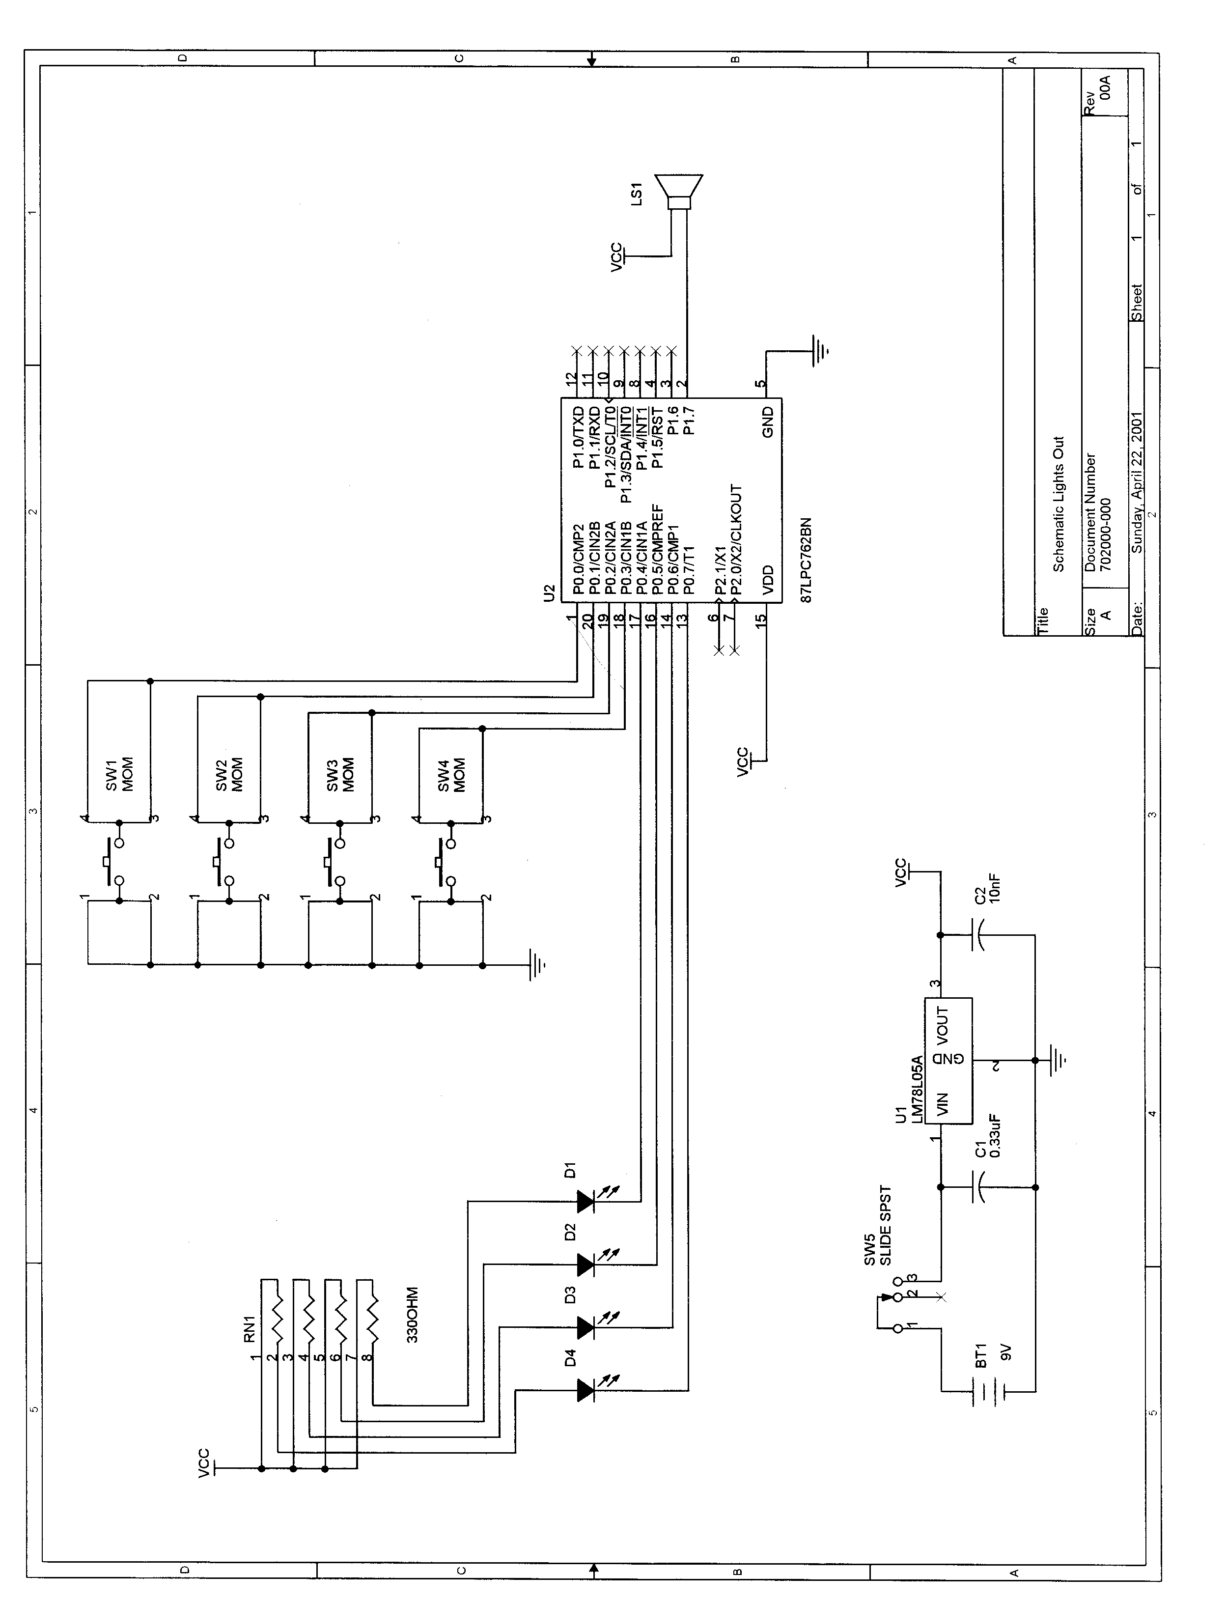

Bill Of Materials

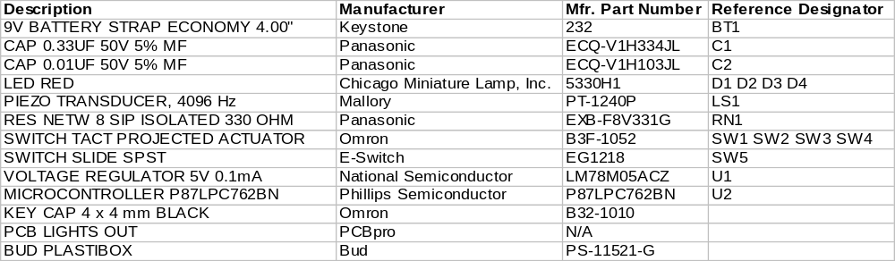

PCB Layout
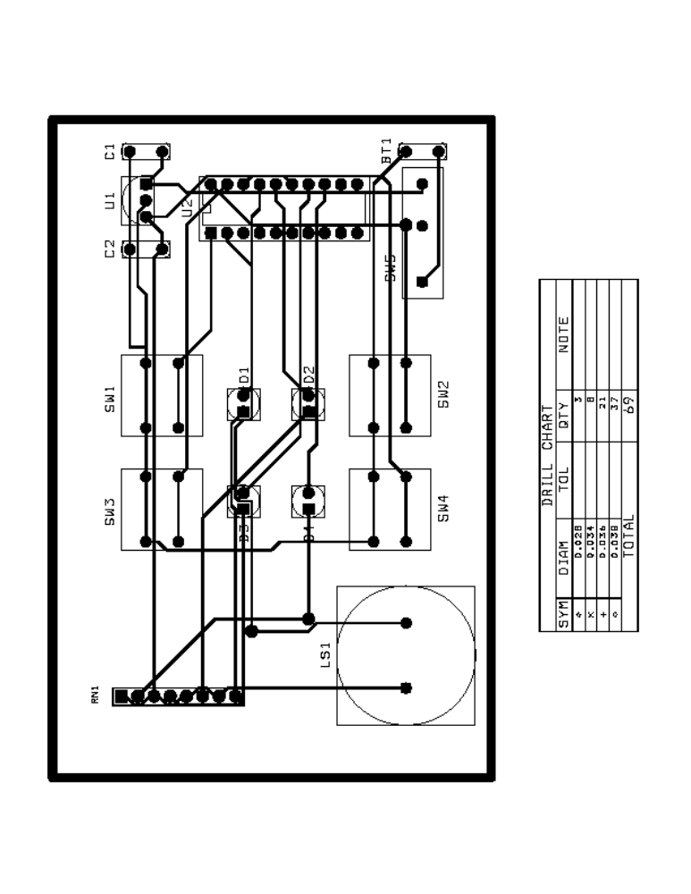

Design Rationale

Many different electrical components are required to make the game. A summary of the chosen parts as well as a cost analysis is located in Appendix D. The style of parts selected for this project was through-hole components. It is important to note that either through-hole or surface mount parts could be used, not a combination of the two. If a combination of types were used, it would require extra machinery to drill the holes and create the surface mount pads. With through-hole technology, a pick and place machine can be used to rapidly create boards. The rationale for each major component is considered below.

Housing
An enclosure for the game design was required in the specifications. The component chosen for the game housing is a Bud Industries Plastibox [6]. The box was chosen for its size and inclusion of a battery compartment as well as PCB mounting holes.

LED
The LED chosen for this design is a Chicago Miniature Lamp PCB mounted LED. The color chosen for the game is red. The main reason for choosing this LED was because of its size. A LED was desired that would reach through the housing case to be seen by the user of the game. This particular LED is tall enough to be mounted on the PCB and reach through the case.
In addition to the LED, a current limiting resistor needs to be added to the circuit. The LED acts almost like a short circuit when active, and would draw enough current to destroy the port of the microcontroller. The LEDs chosen use 20 mA in normal operation. Therefore, a resistance value was chosen to limit the current from the five volt source. The resistance value chosen was 330 Ω because this value provides approximately 15 mA of current that is safe to use on the port of the selected microcontroller. A resistor network of four isolated 330 Ω resistors was chosen because of its small size and low cost.

Microcontroller
The microcontroller that was decided upon is the Phillips 87LPC762 series [1]. The specific microcontroller selected is Phillips part number P87LPC762BN. The style of packaging selected was DIP20. This microcontroller is a derivative of the traditional 8051 microcontroller with additional features. There were several reasons why this microcontroller was selected over other choices.
- Low Power
- Low Pin Count
- Low cost
- LED driver capabilities
- Internal RC oscillator

The game will be powered by a nine-volt battery; therefore, power consumption was a major issue. The 87LPC762 microcontroller is a low power device. The switches and LEDs use only eight bits of data, or one port on an 8051. Therefore, all four standard ports were not needed. The 87LPC762 is also able to drive the LEDs without external hardware, a cost cutting measure. Another feature of the selected microcontroller is the internal RC oscillator. This feature allows the microcontroller to use an internal 6 MHz clock instead of an external quartz or ceramic oscillator.

Speaker
The speaker chosen for this design is a Mallory PT-1240P Piezo Transducer [2]. This component mounts directly on the PCB with two through-hole pins. The device uses a relatively small amount of power, approximately 0.5 mA when operating. Again, power consumption is a major issue in the design of this game. The device can be driven by a simple square wave of variable frequency from one of the microcontroller port pins.

Switches
The switches chosen for the game play are Omron Momentary Tact Switches [5]. The components are through-hole and mount directly on the PCB. The main reason for the choice of switch was the size. The switch must reach through the top of the housing case to be effective. This model of switch has a projected actuator to which a key cap can be attached. Therefore, the switch will be raised through the housing case.
The switch chosen for the power control is an E-Switch SPST slide switch [8]. A slide switch was desired for the game. The switch chosen fits this specification and is also cost effective.

Voltage Regulator
The voltage regulator chosen for this design is a National Semiconductor Positive 5V Regulator [3]. There are several varieties of five-volt voltage regulators. This specific part was chosen because it is a low power device, supplying 100 mA of current. It was expected that under normal operating conditions, the system would draw approximately 31 mA of current. Therefore, this device fits the system requirements.
Input and output capacitors are required for this voltage regulator. The values given in the data sheet are 0.33 μF and 0.01μF on the input and output side respectively. The capacitor chosen for this design is a Panasonic Metallized Film Capacitor [7]. The device was chosen because of its small size and low cost.

Software

The software for this design project was written exclusively in the C programming language. The Keil μVision2 compiler was used to simulate the microcontroller and to create the assembly language. A basic layout of the states of the program was required before actual coding to create a sense of direction. The software flowchart is shown on the next page.
There are only a few functions that perform the bulk of the work in this software design. These functions are INPUT and PRESS. The input function scans the low four bits of Port 0 for a switch press. When a switch press is detected, the function returns the value of the switch pressed. The press function uses the value obtained from the input function and performs the logic that sets the next LED state as described in Appendix B.
The INITIAL function is a variation on the INPUT function. Its purpose is to wait for a button to be pressed when the game is begun. A counter variable is incremented until a button is pressed. The purpose of the counter variable is to seed the SRAND function in C to create a different set of random numbers each time the game is run. The random function is used to create a random pattern to display on the LEDs.
The BEEP function outputs a square wave of the selected frequency using Timer 1 to Port 1 bit 7, the speaker port [4]. The CLK function is the interrupt service register that reloads Timer 1 to continue outputting the square wave. The WIN function simply strobes the LEDs to signify that the player has successfully turned all the lights off. The DELAY function creates a delay in milliseconds using Timer 0. The DISPL function outputs the desired state of the LEDs and sounds the speaker for the button pressed.
Each function is described in the actual C code. The arguments as well as outputs are described before each function.

Software Flowchart

Wait for Initial Button

START

WIN

If all LEDs are off.

Wait for User to Press Button
Change Button States
Compliment state of LED associated with button pushed and all LEDs horizontal and vertical to the switch pressed (See Appendix B).
Wait Timeout

POWER DOWN

C Code

MAIN.C

#include <reg51.h>
#include <stdlib.h>
#include <project.h>

void main( void )
{
char button;

EA=1;
TMOD = 0x11; //Set Timer 0 and Timer 1 into 16 bit Timer mode

RESTART: //Label to restart if player wins
win(); //Flash lights and sound speaker

/* Setup Powerdown Timer */
ET0=1;
TH0=(-50000)>>8;
TL0=(-50000)&0xFF;
TR0=1;

initial(); //Set random initial light pattern

while(1) //Repeat forever
{

button=input(); //Read switches to get input
press(button); //Change LED's according to switch pressed

if( led_read() == 0 ) //Check for winning state
{
goto RESTART; //If player won, then restart
}
}
}

PROJECT.H

/********************************************************/
/* Define Function Prototypes */
/********************************************************/
unsigned int get_seed( void );
void initial( void );
char input( void );
void output( char state );
void delay( unsigned int t_delay );
void displ( char state, char button );
void press( char button );
void win( void );
void beep( char mode );
void clk( void );

#define uchar unsigned char
#define INPUT_MASK 0x0F
#define OUTPUT_MASK 0xF0
#define PORT P0
#define N_MILLI 1000
#define FLASH_MAX 4
#define SPEAKER
#define TONE_L 15

/********************************************************/
/* Define Macros */
/********************************************************/
#define read() ( ~PORT & INPUT_MASK )
#define led_read() ( ~PORT & OUTPUT_MASK ) >> 4

FUNCTION.C

#include <reg51.h>
#include <stdlib.h>
#include <project.h>

/********************************************************/
/* Setup Power Down Mode */
/********************************************************/
unsigned int timeout=0; //Timeout counter global variable

void powdown( void ) interrupt 1 using 2
{
timeout++;
if( timeout == 500 )
{
PORT=0xFF;
PCON |= 0x02;
}
}

/********************************************************/
/* Setup Speaker */
/********************************************************/
#ifdef SPEAKER

#define SPKR P1 //Port that speaker is on
#define SPKR_INIT 0xFF //Turn off speaker
#define SPKR_BIT 0x80 //Bit that speaker is on

/********************************************************/
/* Speaker Tone Periods */
/* */
/* Note Frequency (Hz) Period (us) Period/2 (us) */
/* ---- -------------- ----------- ------------- */
/* A 440.00 2273 1136 */
/* B 493.88 2025 1012 */
/* C# 554.37 1804 902 */
/* D 587.33 1703 851 */
/********************************************************/

#define PER_01 1136
#define PER_02 1012
#define PER_04 902
#define PER_08 851

uchar spkr_out = SPKR_INIT; //Speaker state global variable

//Period Table for button pressed
int period[] = { 0, PER_01, PER_02, 0, PER_04, 0, 0, 0, PER_08, 0, 0, 0, 0, 0, 0, 0 };

int *p_per; //Pointer for table access

#endif

/********************************************************/
/* Define Functions */
/********************************************************/

/********************************************************/
/* Get_Seed Function */
/* */
/* INPUT: NONE */
/* OUTPUT: int value of states before button pressed */
/* */
/* The get_seed function takes no arguments and counts */
/* cycles until a button is pressed to begin the game. */
/* The function returns this integer value for use with */
/* the srand seed function to enable random light order.*/
/********************************************************/
unsigned int get_seed( void )
{
unsigned int i=1,j=1,k=1;
char new, old = 0x00, val = 0x00, val2;

output(0);
new = read();

while( val == old )
{
val = (old^new)&new;
new = read();
i++;

if( i%8000==0 )
{
k++;
if( k%8==0 )
{
output(j);
j=j<<1;
if(j==0x10)
j=1;
}
}

if( i==0xFFFE )
i=1;
}

val2=val;

while(val2 == new)
{
val = (old^new)&new;
new = read();
}

return i;
}

/********************************************************/
/* Initial Function */
/* */
/* INPUT: NONE */
/* OUTPUT: char value of the initial state of lights */
/* */
/* The initial function takes no arguments and returns */
/* a random initial state for the lights. */
/********************************************************/
void initial( void )
{
char i_state;

srand( get_seed() );

i_state=1+rand()%15;
output( i_state );
}

/********************************************************/
/* Input Function */
/* */
/* INPUT: NONE */
/* OUTPUT: char value of the state of switches */
/* */
/* The input function takes no arguments and returns */
/* the current state of the switches when a button is */
/* pressed. A '1' indicates the switch was pressed; a */
/* '0' indicates a switch is not pressed. */
/********************************************************/
char input( void )
{
char new, old = 0x00, val = 0x00, val2;

new = read();

while( val == old )
{
val = (old^new)&new;
new = read();
}

val2=val;

while(val2 == new)
{
val = (old^new)&new;
new = read();
}
return val;
}
/********************************************************/
/* Output Function */
/* */
/* INPUT: state - desired state for LED's */
/* OUTPUT: NONE */
/* */
/* The output function takes a character state argument */
/* and outputs the low 4 bits to the output port. A '1'*/
/* turns the LED on; a '0' turns the LED off. */
/********************************************************/
void output( char state )
{
PORT = ~( (state << 4) & 0xF0);
}

/********************************************************/
/* Delay Function */
/* */
/* INPUT: t_delay-time of delay in milliseconds */
/* OUTPUT: NONE */
/* */
/* The delay function takes an integer time argument in */
/* milliseconds. The program then spins in a loop for */
/* the indicated amount of time. */
/********************************************************/
void delay( unsigned int t_delay )
{
unsigned int i;

ET0=0;

for(i=t_delay; i>0; i--)
{
TH0 = -N_MILLI>>8;
TL0 = -N_MILLI&0xFF;
TR0=1;
while(!TF0);
TF0=TR0=0;
}

ET0=1;
}

/********************************************************/
/* Displ Function */
/* */
/* INPUT: state - state of lights to output */
/* button - switch pressed */
/* OUTPUT: NONE */
/* */
/* The displ function takes a character LED state */
/* argument and a character button pressed argument. */
/* The function outputs the state of the lights and */
/* sounds the corresponding tone of the switch pressed */
/********************************************************/
void displ( char state, char button )
{
output( state );
#ifdef SPEAKER
beep( button );
#endif
}

/********************************************************/
/* Press Function */
/* */
/* INPUT: button - switch pressed */
/* OUTPUT: NONE */
/* */
/* The press function takes an character switch state */
/* argument. The function then inverts the light and */
/* the lights that are horizontal and vertical to the */
/* light pressed. */
/********************************************************/
void press( char button )
{
char new, old;
old = led_read();

TR0=0;
ET0=0;
timeout=0;

switch( button )
{
case 0x01:
new = (~old&0x07) | (old&0x08);
break;
case 0x02:
new = (~old&0x0B) | (old&0x04);
break;
case 0x04:
new = (~old&0x0D) | (old&0x02);
break;
case 0x08:
new = (~old&0x0E) | (old&0x01);
break;
default:
new=old;
break;
}
displ( new, button );
}

/********************************************************/
/* Win Function */
/* */
/* INPUT: NONE */
/* OUTPUT: NONE */
/* */
/* The press function takes a character switch state */
/* argument. The function then inverts the light and */
/* the lights that are horizontal and vertical to the */
/* light pressed. */
/********************************************************/
void win( void )
{
char i,j;
for( i=0; i<FLASH_MAX; i++)
{
for(j=0; j<4; j++)
{
displ( 0x01 << j, 0x01<<j );
}
}
}

/********************************************************/
/* Speaker Specific Functions */
/********************************************************/
#ifdef SPEAKER

/********************************************************/
/* Beep Function */
/* */
/* INPUT: mode - switch pressed to output tone for */
/* OUTPUT: NONE */
/* */
/* The beep function takes a char mode argument that is */
/* the switch pressed to output the tone for. The */
/* function sets the global pointer with the index and */
/* initializes Timer 1 with the associated period. The */
/* tone is allowed to continue for time TONE_L */
/********************************************************/
void beep( char mode )
{
p_per = &period[mode];
if( *p_per != 0 )
{
/* Enable timer */
TH1=-(*p_per)>>8;
TL1=-(*p_per)&0xFF;
TR1=1;
ET1=1;
}

delay(TONE_L);

/* Disable timer */
ET1=0;
TR1=0;
SPKR = SPKR_INIT;
}

/********************************************************/
/* Clk Function */
/* */
/* INPUT: NONE */
/* OUTPUT: NONE */
/* */
/* The clk function is an interrupt service routine. It */
/* takes no arguments and returns nothing. The function*/
/* sets up Timer 1 to create a square wave of frequency */
/* pointed to by the p_per pointer. */
/********************************************************/
void clk( void ) interrupt 3 using 1
{
TH1 = -(*p_per)>>8;
TL1 = -(*p_per)&0xFF;
spkr_out = spkr_out^SPKR_BIT;
SPKR = spkr_out;
}

#endif

Output
The listing and linker files associated with the project are located in Appendix E and Appendix F respectively. A HEX-80 programming file of the code is located in Appendix G.

Program Size

Data Space
The size of the data space required can be obtained from the M51 linker file located in Appendix F. The size of the data memory space required is found by adding the size of the data segments. The total size of the data space is 69 bytes.
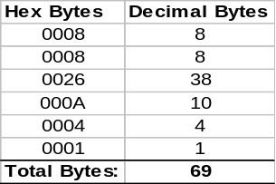

Code Space
The size of the compiled and assembled code can be obtained from the M51 linker file located in Appendix F. The size of the executable code is found by adding the size of the code segments. The total size of the code space is 1071 bytes.
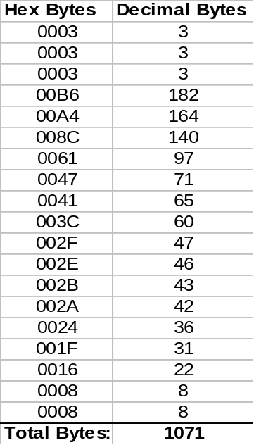

Simulation

Keil μVision2 software was used for all programming and simulation for this project. This software was chosen because it supports a wide range of microcontrollers, including extensive types of 8051 microcontrollers. The microcontroller used for this project, Phillips 87LPC762, was supported in full by the Keil software.
A project file was created that included the MAIN.C file containing the logic of the program. The PROJECT.H header file was created to contain the prototypes of the functions used for this program. The FUNCTION.C file was also created, and the function definitions as well as other macros were placed in this file. This action was taken to minimize the amount of information contained in the main file and to create understandable and concise. The global definitions are also all located in one place to ease changes if needed.
Continual testing of the software was done throughout the design phase. This task assured that the finished product would function according to the specifications. Each individual function was tested separately to ensure it functioned as expected. Once the final code was completed, an extensive test of the software was made.
This extensive test used the debugger supplied with the Keil μVision2 software. The input and output, Port 0, of the microcontroller was displayed under the peripherals. Port 1 was also displayed to show the speaker output. Various combinations of inputs to the game state were tested to ensure that the game was functional.

Production Test Procedure

It is important to have a well-documented production test procedure. The boards will be created by production workers, therefore, a 100 percent test is required on the assembly line.

LIGHTS OUT PRODUCTION POWER UP TEST
- Connect the 9 V power supply to the battery strap.
- Slide the main power switch to the “ON” position.
- Check for flashing lights and speaker playing tones. If the lights flashed and speaker sounded, skip to step 5.

- Board is non-functional. Place in troubleshooting bin. Skip to Step 6.
- Board is functional. Place initials sticker on board.
- END TEST

Design Analysis

Battery Life
The power supply used in this system is a common 9V battery. Battery life was an important design specification in this project. The Phillips 87LPC762 microcontroller draws 15 mA of current under normal operating conditions. Each LED draws approximately 15 mA of current when active. Therefore, the maximum current drawn by the LEDs is 60 mA. The Mallory audio transducer draws approximately 1 mA of current when active.
Battery life estimates will be based on an average of three LEDs active. It is clear that more or less LEDs may be active at any given instant of time, but an average is all that is required for this estimate. Therefore, the LEDs will draw 45 mA of current in battery life estimation. The sum of the microcontroller, average LED, and speaker current is 61 mA. Typical operating conditions for estimation of battery life will be a current draw of 61 mA.
The manufacturer supplied data for an Energizer 9V battery was used for typical battery life specifications [9]. This battery is the Energizer Consumer/OEM Model 522. A graph of service hours to constant current discharge was referenced for the operating condition of 61 mA. The graph showed that the battery would last for approximately five service hours under the normal operating conditions specified previously.

Cost Analysis
A summary of the parts used and associated cost is located in Appendix D. The cost shown for each part with a vendor is an actual cost with the exception of the printed circuit board. It was assumed that Siemens would be the actual manufacturer, but an actual cost was not obtained. Therefore, an estimate was used for analysis.

PCB

A price quote for producing the PCB was found at PCBpro.com using the Instant Quote tool. The specifications used for obtaining the price quote were:

Layers = 2
Board Size = 2.5” X 2”
Base Copper Weight = 0.5 oz
Thickness = 0.062
Smallest Hole >0.020
Number of Holes = 69
Minimum Spacing >= 0.007
Solder Mask = 2 Side LPI
Plate Type = Hot Air Level
Nomenclature = None
Surface Mount = No
Special = None
Gold Finger = 0
Electrical Test = No
Number of Test Point = 0

The summary of the prices obtained from the Instant Quote tool is located in Appendix C. A single board run would cost $727.50 including a $135 one-time tooling cost. A run of 100,000 boards would cost $1.35 per unit plus the $135 one-time tooling cost. The unit cost including the $135 fee per board is $1.35135. There is a significant cost savings in mass production.

Labor
The labor cost is the cost of producing one of the boards. In the single unit case, the cost was based on the assumption that an intern would be used for five hours at twelve dollars and hour totaling $60. In the bulk labor price, I practiced assembling a single board and found that it took me about 3.5 minutes to assemble and test the board. The work would be done by a minimum wage worker at a rate of $5.25 per hour. The cost for producing a single board would then be approximately $0.30625 if a minimum wage worker was performing the work.

Total Cost

The total cost of producing a single unit is $797.74. The total cost of producing a mass-produced unit is $9.67. The large difference occurs because of the large cost for producing a single PCB. A complete run of 100,000 units would cost $967,000 at $9.67 per board.

Works Cited

- “87LPC762; Low power, low price, low pin count (20 pin) microcontroller with 2 kB OTP.” Phillips Semiconductors. Available: http://www.phillipssemiconductor.com/pip/P87LPC762BD. 15 April 2001.
- “External Drive Piezo Transducers.” Mallory. Available: http://www.nacc-mallory.com/pdf/audible/Transducer/externaldrv.pdf. 21 April 2001.
- “LM78L05: 3-Terminal Positive Voltage Regulators.” National Semiconductor. Available: http://www.national.com/pf/LM/LM78L05.html. 15 April 2001.
- MacKenzie, I. Scott. The 8051 Microcontroller. Upper Saddle River: Prentice-Hall, Inc., 1999, pp. 223-226.
- “Miniature, Space Saving, Tactile Switch.” Omron. Available: http://oeiweb.omron.com/oei/. 21 April 2001.
- “Plastibox Style F.” Bud Industries, Inc. Available: http://www.budind.com/cgi-bin/view?part=pl-f. 22 April 2001.
- “Stacked Metallized Film Capacitor.” Panasonic. Available: http://www.panasonic.com/industrial_oem/electronic_components/pdf/ef040_ecqv_dne.pdf. 22 April 2001.
- “Sub-Miniature Slide Switches.” E-Switch. Available: http://www.e-switch.com/newsite/showser.html?ser=EG. 21 April 2001.
- “Technical Marketing Datasheets.” Energizer. Available: http://data.energizer.com/. 22 April 2001.

Appendixes
Appendix A
Promotional Flier

©
Lights
Out!

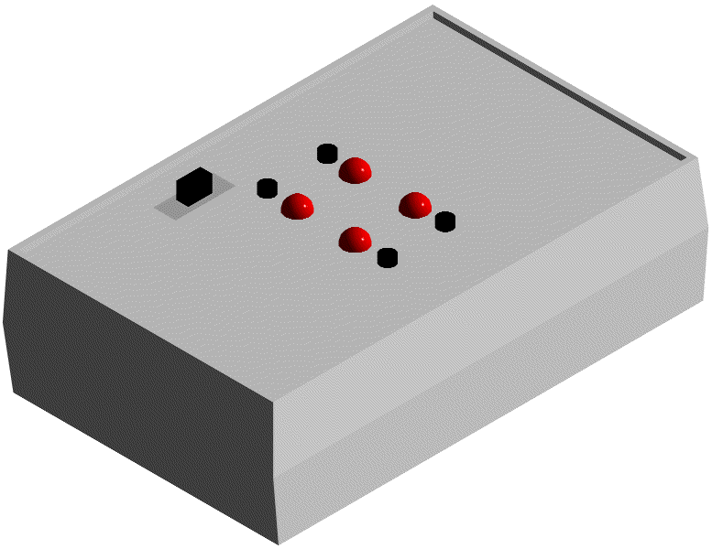
Lights Out© is an action packed new game that provides entertainment for the whole family. The object of the game is simple: try to make all of the lights turn off. The game will start with a random number of lights lit. Pressing the button next to a light switches the light from its current state. Beware, all lights that are vertical or horizontal from the one pressed are also switched!
Lights
Out!

Once I picked it up, I couldn’t put it down!

LO of Lights Out, CA
For example, suppose the lights were as shown below and button one was pressed. The lights would change as shown. You have to continue to press the buttons in order to make all of the lights turn off.
1
2
3
4
1
2
3
4
Button 1 Pressed
Lights Change

©
Lights
Out!
©

Are you up to the challenge of ?
Still interested? Visit us on the web at http://www.umr.edu/~jlai/lightsout to find out more information.
Tel: (573) 341-8945 • Fax: (978) 246-8266 • jlai@umr.edu
Appendix B
Game Play

Object
The object of the game is to make all of the lights turn off by pressing different combinations of buttons.

Startup
When the game is first turned on or when a game is won, the LEDs will strobe. Next, the game will strobe the lights in a slower manner waiting for the user to press any button to start the game. A random pattern will be displayed on the LED grid.

Game Play
When a button is pressed, the state of the light changes (from on to off or vice-versa) as well as the states of the lights that are horizontal or vertical to the button pressed.

For example, suppose the lights were as shown below and button four was pressed. The lights would change as shown. The goal is to continue to press the buttons in order to make all of the lights turn off.

4
3
2
1
4
3
2
1
Button 4 Pressed
Lights Change

Winning
The game is won when all of the lights have been turned off. The game will strobe the LEDs signifying that the user has found the winning combination and the game will restart.

Appendix C
PCB Cost Analysis

The following price tables were found from the PCBpro Instant Quote tool using the specifications given in the PCB cost analysis section.

Single Board Pricing
Price Matrix (Per Unit Pricing)
Select your desired price to order or save quote.
Note: Price does not include: taxes, shipping or tooling charges (for tooling see below)
Quantity | 2 Day | 3 Day | 4 Day | 1 Week | 2 Week | 3 Week | 4 Week | 5 Week
1 | $1,066.50 | $948.00 | $918.38 | $888.75 | $711.00 | $651.75 | $622.12 | $592.50
2 | $533.25 | $474.00 | $459.19 | $444.38 | $355.50 | $325.88 | $311.06 | $296.25
4 | $266.62 | $237.00 | $229.59 | $222.19 | $177.75 | $162.94 | $155.53 | $148.12
10 | $106.65 | $94.80 | $91.84 | $88.87 | $71.10 | $65.17 | $62.21 | $59.25
25 | $42.66 | $37.92 | $36.73 | $35.55 | $28.44 | $26.07 | $24.89 | $23.70
50 | $21.33 | $18.96 | $18.37 | $17.77 | $14.22 | $13.04 | $12.44 | $11.85
100 | $10.66 | $9.48 | $9.18 | $8.89 | $7.11 | $6.52 | $6.22 | $5.92
200 | $5.42 | $4.82 | $4.67 | $4.52 | $3.61 | $3.31 | $3.16 | $3.01
500 | $2.66 | $2.36 | $2.29 | $2.21 | $1.77 | $1.62 | $1.55 | $1.48
Quantity = 1 , Lead time = 5 Week ,Piece price = $ 592.50 , One-time tooling = $ 135.00 , Test fixture = $ 0.00
Your total cost = $ 727.50 plus shipping

100,000 Unit Pricing
Price Matrix (Per Unit Pricing)
Select your desired price to order or save quote.
Note: Price does not include: taxes, shipping or tooling charges (for tooling see below)
Quantity | 2 Day | 3 Day | 4 Day | 1 Week | 2 Week | 3 Week | 4 Week | 5 Week
100000 |  |  |  |  |  | $1.49 | $1.42 | $1.35
2 | $533.25 | $474.00 | $459.19 | $444.38 | $355.50 | $325.88 | $311.06 | $296.25
4 | $266.62 | $237.00 | $229.59 | $222.19 | $177.75 | $162.94 | $155.53 | $148.12
10 | $106.65 | $94.80 | $91.84 | $88.87 | $71.10 | $65.17 | $62.21 | $59.25
25 | $42.66 | $37.92 | $36.73 | $35.55 | $28.44 | $26.07 | $24.89 | $23.70
50 | $21.33 | $18.96 | $18.37 | $17.77 | $14.22 | $13.04 | $12.44 | $11.85
100 | $10.66 | $9.48 | $9.18 | $8.89 | $7.11 | $6.52 | $6.22 | $5.92
200 | $5.42 | $4.82 | $4.67 | $4.52 | $3.61 | $3.31 | $3.16 | $3.01
500 | $2.66 | $2.36 | $2.29 | $2.21 | $1.77 | $1.62 | $1.55 | $1.48
Quantity = 100000 , Lead time = 5 Week ,Piece price = $ 1.35 , One-time tooling = $ 135.00 , Test fixture = $ 0.00
Your total cost = $ 135,135.00 plus shipping
Appendix D
System Cost Analysis

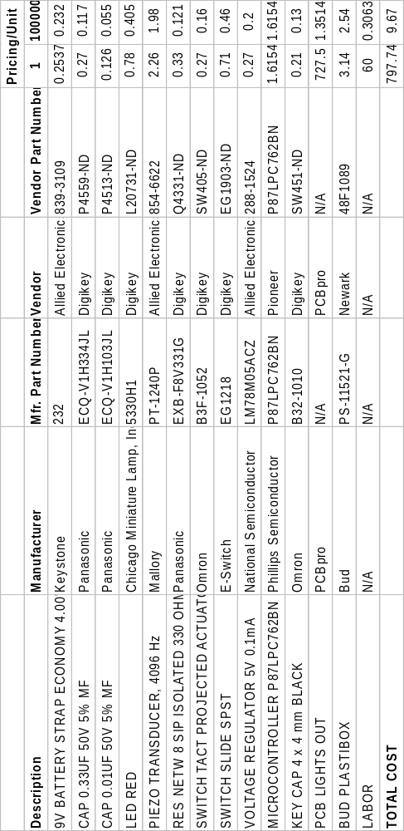
Appendix E
Listing Files

The following is a partial listing of the contents of the MAIN.LST file. The entire contents can be viewed online at the address: http://www.umr.edu/~jlai/lightsout/main.lst. The listing file FUNCTION.LST can be found online at the address: http://www.umr.edu/~jlai/lightsout/function.lst.

C51 COMPILER V6.10 MAIN 04/24/2001 22:24:13 PAGE 1

C51 COMPILER V6.10, COMPILATION OF MODULE MAIN
OBJECT MODULE PLACED IN .\main.OBJ
COMPILER INVOKED BY: C:\Program Files\Keil\C51\BIN\C51.EXE .\main.c DEBUG OBJECTEXTEND CODE

stmt level source

1 #include <reg51.h>
2 #include <stdlib.h>
3 #include <project.h>
4
5 void main( void )
6 {
7 1 char button;
8 1
9 1 EA=1;
10 1 TMOD = 0x11; //Set Timer 0 and Timer 1 into 16 bit Timer mode
11 1
12 1 RESTART: //Label to restart if player wins
13 1
14 1 win(); //Flash lights and sound speaker
15 1
16 1 ET0=1;
17 1 TH0=(-50000)>>8;
18 1 TL0=(-50000)&0xFF;
19 1 TR0=1;
20 1
21 1 initial(); //Set random initial light pattern
22 1
23 1 while(1) //Repeat forever
24 1 {
25 2
26 2 button=input(); //Read switches to get input
27 2 press(button); //Change LED's according to switch pressed
28 2
29 2 if( led_read() == 0 ) //Check for winning state
30 2 {
31 3 goto RESTART; //If player won, then restart
32 3 }
33 2 }
34 1 }
35
C51 COMPILER V6.10 MAIN 04/24/2001 22:24:13 PAGE 2

ASSEMBLY LISTING OF GENERATED OBJECT CODE

; FUNCTION main (BEGIN)
; SOURCE LINE # 5
; SOURCE LINE # 6
; SOURCE LINE # 9
0000 D2AF SETB EA
; SOURCE LINE # 10
0002 758911 MOV TMOD,#011H
; SOURCE LINE # 12
0005 RESTART:
; SOURCE LINE # 14
0005 120000 E LCALL win
; SOURCE LINE # 16
0008 D2A9 SETB ET0
; SOURCE LINE # 17
000A 758C3C MOV TH0,#03CH
; SOURCE LINE # 18
000D 758AB0 MOV TL0,#0B0H
; SOURCE LINE # 19
0010 D28C SETB TR0
; SOURCE LINE # 21
0012 120000 E LCALL initial
0015 ?C0002:
; SOURCE LINE # 23
; SOURCE LINE # 24
; SOURCE LINE # 26
0015 120000 E LCALL input
0018 8F00 R MOV button,R7
; SOURCE LINE # 27
001A 120000 E LCALL _press
; SOURCE LINE # 29
001D E580 MOV A,P0
001F F4 CPL A
0020 54F0 ANL A,#0F0H
0022 FF MOV R7,A
0023 C4 SWAP A
0024 540F ANL A,#0FH
0026 70ED JNZ ?C0002
; SOURCE LINE # 30
; SOURCE LINE # 31
0028 80DB SJMP RESTART
; FUNCTION main (END)

MODULE INFORMATION: STATIC OVERLAYABLE
CODE SIZE = 42 ----
CONSTANT SIZE = ---- ----
XDATA SIZE = ---- ----
PDATA SIZE = ---- ----
DATA SIZE = ---- 1
IDATA SIZE = ---- ----
BIT SIZE = ---- ----
END OF MODULE INFORMATION.

C51 COMPILATION COMPLETE. 0 WARNING(S), 0 ERROR(S)

Appendix F
Linker Files

The following is a partial listing of the contents of the PROJECT.M51 file. The entire contents can be viewed online at the address: http://www.umr.edu/~jlai/lightsout/linker.doc.

BL51 BANKED LINKER/LOCATER V4.03 04/21/2001 23:02:03 PAGE 1

BL51 BANKED LINKER/LOCATER V4.03, INVOKED BY:
C:\PROGRAM FILES\KEIL\C51\BIN\BL51.EXE main.obj TO CpE 213 - Semester Project

MEMORY MODEL: SMALL

INPUT MODULES INCLUDED:
main.obj (MAIN)
C:\PROGRAM FILES\KEIL\C51\LIB\C51S.LIB (?C_STARTUP)
C:\PROGRAM FILES\KEIL\C51\LIB\C51S.LIB (?C?UIDIV)
C:\PROGRAM FILES\KEIL\C51\LIB\C51S.LIB (?C?SIDIV)
C:\PROGRAM FILES\KEIL\C51\LIB\C51S.LIB (?C?ILDPTR)
C:\PROGRAM FILES\KEIL\C51\LIB\C51S.LIB (RAND)
C:\PROGRAM FILES\KEIL\C51\LIB\C51S.LIB (?C_INIT)

LINK MAP OF MODULE: CpE 213 - Semester Project (MAIN)

TYPE BASE LENGTH RELOCATION SEGMENT NAME
-----------------------------------------------------

* * * * * * * D A T A M E M O R Y * * * * * * *
REG 0000H 0008H ABSOLUTE "REG BANK 0"
REG 0008H 0008H ABSOLUTE "REG BANK 1"
DATA 0010H 0026H UNIT ?DT?MAIN
DATA 0036H 000AH UNIT _DATA_GROUP_
DATA 0040H 0004H UNIT ?DT?RAND?RAND
IDATA 0044H 0001H UNIT ?STACK

* * * * * * * C O D E M E M O R Y * * * * * * *
CODE 0000H 0003H ABSOLUTE
0003H 0008H *** GAP ***
CODE 000BH 0003H ABSOLUTE
000EH 000DH *** GAP ***
CODE 001BH 0003H ABSOLUTE
001EH 3FE2H *** GAP ***
CODE 4000H 00B6H UNIT ?C?LIB_CODE
CODE 40B6H 00A4H UNIT ?PR?GET_SEED?MAIN
CODE 415AH 008CH UNIT ?C_C51STARTUP
CODE 41E6H 0061H UNIT ?PR?_PRESS?MAIN
CODE 4247H 0047H UNIT ?PR?_BEEP?MAIN
CODE 428EH 0041H UNIT ?PR?RAND?RAND
CODE 42CFH 003CH UNIT ?PR?CLK?MAIN
CODE 430BH 002FH UNIT ?PR?WIN?MAIN
CODE 433AH 002EH UNIT ?PR?INPUT?MAIN
CODE 4368H 002BH UNIT ?C_INITSEG
CODE 4393H 002AH UNIT ?PR?MAIN?MAIN
CODE 43BDH 0024H UNIT ?PR?_DELAY?MAIN
CODE 43E1H 001FH UNIT ?PR?POWDOWN?MAIN
CODE 4400H 0016H UNIT ?PR?INITIAL?MAIN
CODE 4416H 0008H UNIT ?PR?_OUTPUT?MAIN
CODE 441EH 0008H UNIT ?PR?_DISPL?MAIN

Appendix G
Hex Code

:10439300D2AF75891112430BD2A9758C3C758AB0C3
:1043A300D28C12440012433A8F361241E6E580F470
:0A43B30054F0FFC4540F70ED80DBDE
:10436800023000000135FF2020100000047003F423
:104378000000038600000000000003530000000056
:0A438800000000000000000000002B
:03000B000243E1CC
:1043E100C0E0C0D00531E53170020530B4D00BE535
:0F43F10030B407067580FF438702D0D0D0E0328A
:1040B600753700753801753900753A01753B00751D
:1040C6003C01E4F53EF53FFF124416E580F4540F3B
:1040D600F53DE53F653E7060E53E653D553DF53F86
:1040E600E580F4540FF53D0538E53870020537AE26
:1040F60037FF7C1F7D40124000ED4C7029053CE5E2
:104106003C7002053B5407701DAF3A124416E53A5F
:1041160025E0F53AE53933F539E53A641045397065
:1041260005F539753A01E538B4FEA7E537B4FFA2BF
:10413600753700753801809AAF3FEFB53D11E53E02
:10414600653D553DF53FE580F4540FF53D80EBAEFA
:0341560037AF3848
:014159002243
:104400001240B61242C512428E7C007D0F124055FA
:06441000ED04FF0244165A
:10433A00E4FFFEE580F4540FFDEEB5070CEF6D5D6A
:10434A00FEE580F4540FFD80F0AC06ECB5050CEFE9
:0D435A006D5DFEE580F4540FFD80F0AF06B0
:014367002233
:08441600EFC454F0F4F580221C
:1043BD00C2A9D3EF9400EE94004016758CFC758A5B
:1043CD0018D28C308DFDC28CC28DEF1F70E41E8013
:0343DD00E1D2A981
:0143E00022BA
:08441E00124416AF05024247EB
:0241E600AD0723
:1041E800E580F454F0FFC4540FFFC28CC2A9E4F573
:1041F80030F531ED24FE601924FE602224FC602B8A
:1042080024077034EFF45407FEEF54084EF5378056
:1042180029EFF4540BFEEF54044EF537801CEFF4ED
:10422800540DFEEF54024EF537800FEFF4540EFE96
:0F423800EF54014EF53780028F37AF3702441E27
:10430B00E4F537E4F538AF387401A807088002C329
:10431B0033D8FCFDFF12441E0538C3E53864809486
:0E432B008440E30537C3E5376480948440D5B1
:014339002261
:10424700EF75F002A42410F9E4FAFBF532F533898F
:104257003412408B45F06020AB32AA3312408BFDFD
:10426700ACF0C3E49DE49CFF3395E08F8DAF05EF81
:10427700F404F58BD28ED2AB7F0F7E001243BDC202
:07428700ABC28E7590FF220F
:03001B000242CFCF
:1042CF00C0E0C0F0C083C082C0D075D008AB32AAA6
:1042DF0033A93412408BFDACF0C3E49DE49CFF3353
:1042EF0095E08F8DAF0DEFF404F58B633580853539
:0C42FF0090D0D0D082D083D0F0D0E0323C
:0300000002415A60
:0C415A00787FE4F6D8FD7581430241A196
:10400000BC000BBE0029EF8DF084FFADF022E4CCA4
:10401000F875F008EF2FFFEE33FEEC33FCEE9DEC6D
:10402000984005FCEE9DFE0FD5F0E9E4CEFD22EDB3
:10403000F8F5F0EE8420D21CFEADF075F008EF2FFD
:10404000FFED33FD4007985006D5F0F222C398FDEE
:054050000FD5F0EA228B
:10405500C2D5EC30E709B2D5E4C39DFDE49CFCEE86
:1040650030E715B2D5E4C39FFFE49EFE124000C3BE
:10407500E49DFDE49CFC800312400030D507C3E4B9
:064085009FFFE49EFE22F5
:10408B00BB010A89828A83E0F5F0A3E02250068700
:10409B00F009E71922BBFE07E3F5F009E3192289C2
:0B40AB00828A83E493F5F074019322F5
:10428E00AC40AD41AE42AF43780FEFA2E2EC20E678
:10429E0001B35D5E5FF47004FCFDFEFFEF13FFEEF5
:1042AE0013FEED13FDEC13FCD8E08C408D418E42D5
:1042BE008F43EE547FFE228E408F41E4F542F5434C
:0142CE0022CD
:10416600024393E493A3F8E493A34003F68001F299
:1041760008DFF48029E493A3F85407240CC8C3335A
:10418600C4540F4420C8834004F456800146F6DF29
:10419600E4800B0102040810204080904368E47E0E
:1041A600019360BCA3FF543F30E509541FFEE4931E
:1041B600A360010ECF54C025E060A840B8E493A3E5
:1041C600FAE493A3F8E493A3C8C582C8CAC583CA10
:1041D600F0A3C8C582C8CAC583CADFE9DEE780BEC8
:01439200002A
:00000001FF

